Reference for Lab 8
Triggers
Definition
A trigger is a stored procedure in the database which is automatically invoked whenever a special event in the database occurs. Each trigger is always associated with a table.
Creating Triggers
When creating a trigger, you need to specify four pieces of information:
• A unique trigger name
• The table to which the trigger is to be associated
• The action that the trigger should respond to (DELETE, INSERT, or UPDATE) • When the trigger should be executed (before or after processing)
Triggers are supported only on tables, not on views.
Events
These special events include DML events (insert, update, or delete) and DDL events (create, alter, or drop).
Let’s consider a student_marks table which stores the information of the marks of a student in various subjects.
create table student_marks(
roll_no int primary key,
name varchar(50) not null,
english int not null,
maths int not null,
science int not null,
total_marks int
);
We will create a trigger which automatically calculates the total marks when we insert a student data inside the table.
First, let's create a function to compute the total marks of a student.
create or replace function calc_total_marks()
returns trigger
language plpgsql
as $$
declare
total int;
begin
new.total_marks = new.english + new.maths + new.science; return new;
end;
$$;
-- Keywords : new and old
-- insert -> we can use only new keyword
-- delete -> we can use only old keyword
-- update -> both new and old can be used
Basic syntax of Trigger:
create (or replace) trigger [trigger_name]
[before | after]
{insert | update | delete}
on [table_name]
[for each row]
[trigger_body]
Now, we will create the trigger which will utilize the above function.
create or replace trigger tot_marks_insert
before insert
on student_marks
for each row
execute procedure calc_total_marks();
Procedures and functions are equivalent in triggers.
insert into student_marks values
(1,'A',50,60,70),
(2,'B',70,80,90),
(3,'C',20,30,40);
select * from student_marks;
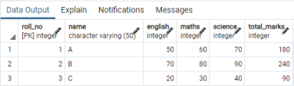Note that the total_marks is already calculated and shown in the table at the time of insertion.
Logging
We will create a student log to insert roll_no, name and the time at which the student marks are added in the student_marks table.
create table student_log(
roll_no int primary key,
name varchar(50),
data time
);
create or replace function logging()
returns trigger
language plpgsql
as $$
begin
insert into student_log
values(new.roll_no,new.name,current_time);
return new;
end;
$$;
Now we will create a trigger which will execute the logging function after every insert into the student_marks table.
create trigger log_trigger
after insert
on student_marks
for each row
execute procedure logging();
select * from student_log;
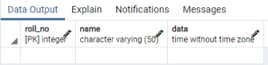
insert into student_marks values
(4,'D',55,40,70);
select * from student_marks;
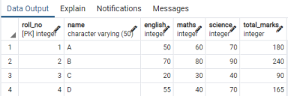
select * from student_log;
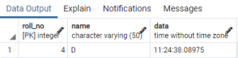
Delete an existing trigger:
drop trigger if exists log_trigger
on student_marks;
Execution time calculation

Python:
import time
start_time = time.time()
<your code>
end_time = time.time()
execution_time = end_time - start_time Pgadmin:
EXPLAIN ANALYZE SELECT * FROM film;

Execution Time Measurement Guidelines

1. PostgreSQL (Using EXPLAIN ANALYZE)
EXPLAIN ANALYZE
SELECT customer_id, SUM(amount) AS total_payment
FROM payment
GROUP BY customer_id
ORDER BY total_payment DESC;
This will display:
- Query plan
- Execution time
- Cost details

2. Python (Using time module)
import psycopg2
import time

conn = psycopg2.connect(
database="dvdrental",
user="postgres",
password="your_password",
host="localhost",
port="5432"
)

cur = conn.cursor()

query = """
SELECT customer_id, SUM(amount) AS total_payment
FROM payment
GROUP BY customer_id
ORDER BY total_payment DESC;
"""

start_time = time.time()

cur.execute(query)
rows = cur.fetchall()

end_time = time.time()

print("Execution Time:", end_time - start_time)

cur.close()
conn.close()

